National Textile University, Faisalabad


Department of Computer Science
Name | Ghulam Habib
Class | BSSE 3rd
Section | A
Registration No | 24-NTU-CS-FL-1154
Assignment | Lab-5
Course Code | DS-2077
Course Name | Data Structures
Submitted To | Sir Basit
Submission Date | 27-October -2025

DATA STRUCTURES
Lab Plan – 1
Exercise-1:

Following is the declaration of Stack class and its member functions. Write the code to implement the definitions of these member functions.

Code :
#ifndef H_stack
#define H_stack
#include <iostream>
using namespace std;
const int MaxSize = 100;
class stack
{
int *arr;
int count;
int stktop;

public:
stack();
~stack();
bool isEmpty();
bool isFull();
int size();
void push(int);
void pop();
void display();
int top();
};
int stack::size()
{
return stktop;
}
void stack::display()
{
for (int i=stktop-1;i>=0;i--)
{
cout<<arr[i]<<" ";
}
cout<<endl;
}
int stack::top()
{
if (stktop != 0)
{
return arr[stktop - 1];
}
return -1;
}
// int stack::size()
// {
// return count;
// }
bool stack::isFull()
{
return (count == MaxSize);
}
bool stack::isEmpty()
{
return (count == 0);
}
void stack::pop()
{
if (!isEmpty())
{
stktop--;
}
else
{
cout << "stack Is empty \n";
}
}
void stack::push(int val)
{
if (!isFull())
{
arr[stktop] = val;
stktop++;
count++;
}
else
{
cout << "Stack is Full \n";
}
}
stack::stack()
{
count = 0;
stktop = 0;
arr = new int[MaxSize];
}
stack::~stack()
{
delete[] arr;
}

#endif

Exercise-2:

Test the Stack class with the following main() function:

Code :

#include <iostream>

#include "stack.h"

using namespace std;

int main()

{

stack st;

cout << "Testing the stack \n";

if (st.isEmpty())

{

cout << "Stack is empty \n";

}

else

{

cout << "Stack is not Empty \n";

}

st.push(10);

st.push(20);

cout << st.top() << "\n";

st.push(30);

st.push(40);

st.display();

st.pop();

st.display();

if (st.isFull())

{

cout << "Stack is full \n";

}

else

{

cout << "Stack is not pull \n";

}

cout << st.size() << endl;

system("pause");

return 0;

}

Screenshot:
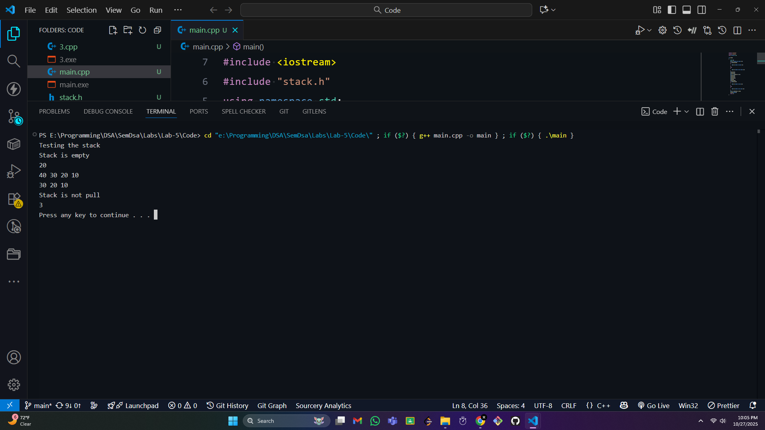

Exercise-3:

Implement the following applications of stack.

1. Infix to Postfix Conversion.

2. Evaluation of Postfix Expressions.

3. Decimal to Binary Conversion.

4. Checking Balanced Symbols.

Code:

#include <iostream>

#include <stack>

#include <string>

using namespace std;

bool checkLowerOrEqualOrder(char ch, char top)

{

char orderArray[5] = {'%', '/', '*', '+', '-'};

int index = 0;

int topIndex = 0;

for (int i = 0; i < 5; i++)

{

if (ch == orderArray[i])

{

index = i;

}

if (top == orderArray[i])

{

topIndex = i;

}

}

return index >= topIndex;

}

string infixToPostFix(string str)

{

stack<char> st;

// char orderArray[5] = {'%', '/', '*', '+', '-'};

int i = 0;

int len = str.length();

string ans = "";

while (i < len)

{

char ch = str[i];

i++;

if (ch >= '0' && ch <= '9')

{

ans.push_back(ch);

}

else if (ch == '(')

{

st.push(ch);

}

else if (ch == ')')

{

while (st.top() != '(')

{

ans.push_back(st.top());

st.pop();

}

if (!st.empty())

{

st.pop();

}

}

else

{

while (!st.empty() && st.top() != '(' && checkLowerOrEqualOrder(ch, st.top()))

{

ans.push_back(st.top());

st.pop();

}

st.push(ch);

}

}

while (!st.empty())

{

ans.push_back(st.top());

st.pop();

}

return ans;

}

int solve(int num1, int num2, char op)

{

if (op == '+')

{

return num1 + num2;

}

else if (op == '-')

{

return num1 - num2;

}

else if (op == '*')

{

return num1 * num2;

}

else

{

return num1 / num2;

}

}

int evalPostfix(string str)

{

int ans = 0;

stack<int> st;

if (str.empty())

{

return ans;

}

else

{

int i = 0;

int len = str.length();

while (i < len)

{

char ch = str[i];

i++;

if (ch >= '0' && ch <= '9')

{

int digit = ch - '0';

st.push(digit);

}

else

{

int op2 = st.top();

st.pop();

int op1 = st.top();

st.pop();

int res = solve(op1, op2, ch);

st.push(res);

}

}

}

return st.top();

}

string decimalToBinary(int number)

{

string ans = "";

stack<int> st;

while (number != 0)

{

int digit = number % 2;

st.push(digit);

number /= 2;

}

while (!st.empty())

{

char ch = st.top() + '0';

ans.push_back(ch);

st.pop();

}

return ans;

}

bool isBalance(string str)

{

stack<char> st;

int i = 0;

int len = str.length();

while (i != len)

{

char ch = str[i];

i++;

if (ch == '(' || ch == '{' || ch == '[')

{

st.push(ch);

}

else{

if(st.empty())

{

return false;

}

char top=st.top();

if ((top == '(' && ch == ')') || (top == '{' && ch == '}')||(top=='['&& ch==']'))

{

st.pop();

}

else{

return false;

}

}

}

return st.empty();

}

int main()

{

cout<<"===============> infix notation to Postfix notatoin <======================= \n";

string str;

cout<<"Enter You Notation \n";

getline(cin, str);

string postFix = "(1+2)+(4+5)";

string postfix = infixToPostFix(str);

cout<<"==========================>Evaluating the postfix <==================\n";

cout << "Result: " << evalPostfix(postfix) << endl;

int number;

cout<<"Enter a Decimal A number \n";

cin>>number;

cout << "Binary : " << decimalToBinary(number) << endl;

string str1="[{({()})}]";

if(isBalance(str1))

{

cout<<"It balance pair of Brackets \n";

}else{

cout<<"Not Balance \n";

}

return 0;

}

Screenshot :
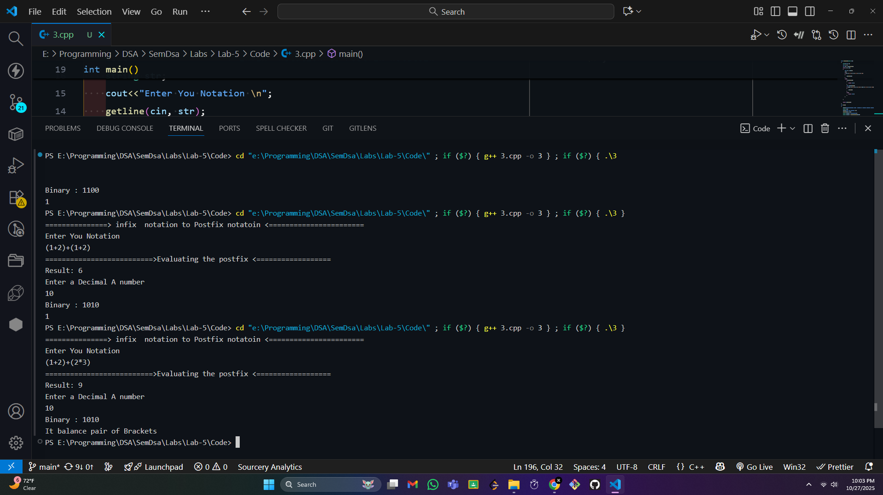

===========End==============

